Statistical Computing

610611104 Pan,Hsing-Cheng

HW10

(1)

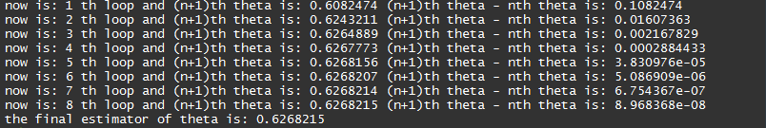我們先利用手寫推導出了E-step跟M-step的form，之後利用程式來迭代參數的值。(手寫推導在下一頁)

停止條件設為當下一次的迭代參數跟上一次的迭代參數誤差的絕對值小於 ${10}^{-7}$。

(2)-(i)

因為 $y_{0}$ 有可能是有小孩但不用再撫養跟真的沒有小孩兩種情況，所以它是從兩種model出來的，所以我們不能直接用poisson distribution來fit這筆資料。

(ii)

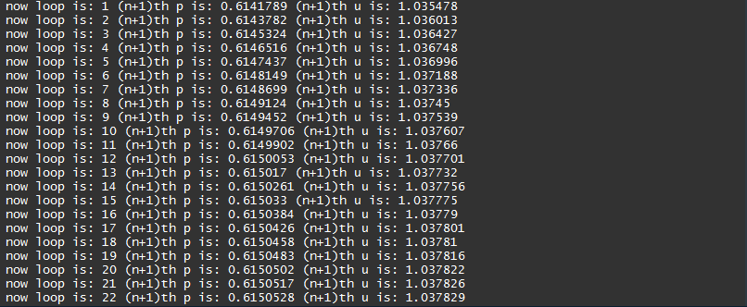利用手寫推出E-step跟M-step，之後利用程式來迭代參數值。然後我們的初始參數為(0.75,0.4)。

所以最後得到從(0.75,0.4)迭代27次滿足停止條件參數誤差值< ${10}^{-6}$，(0.6150556,1.037836)。

手寫推導(1):

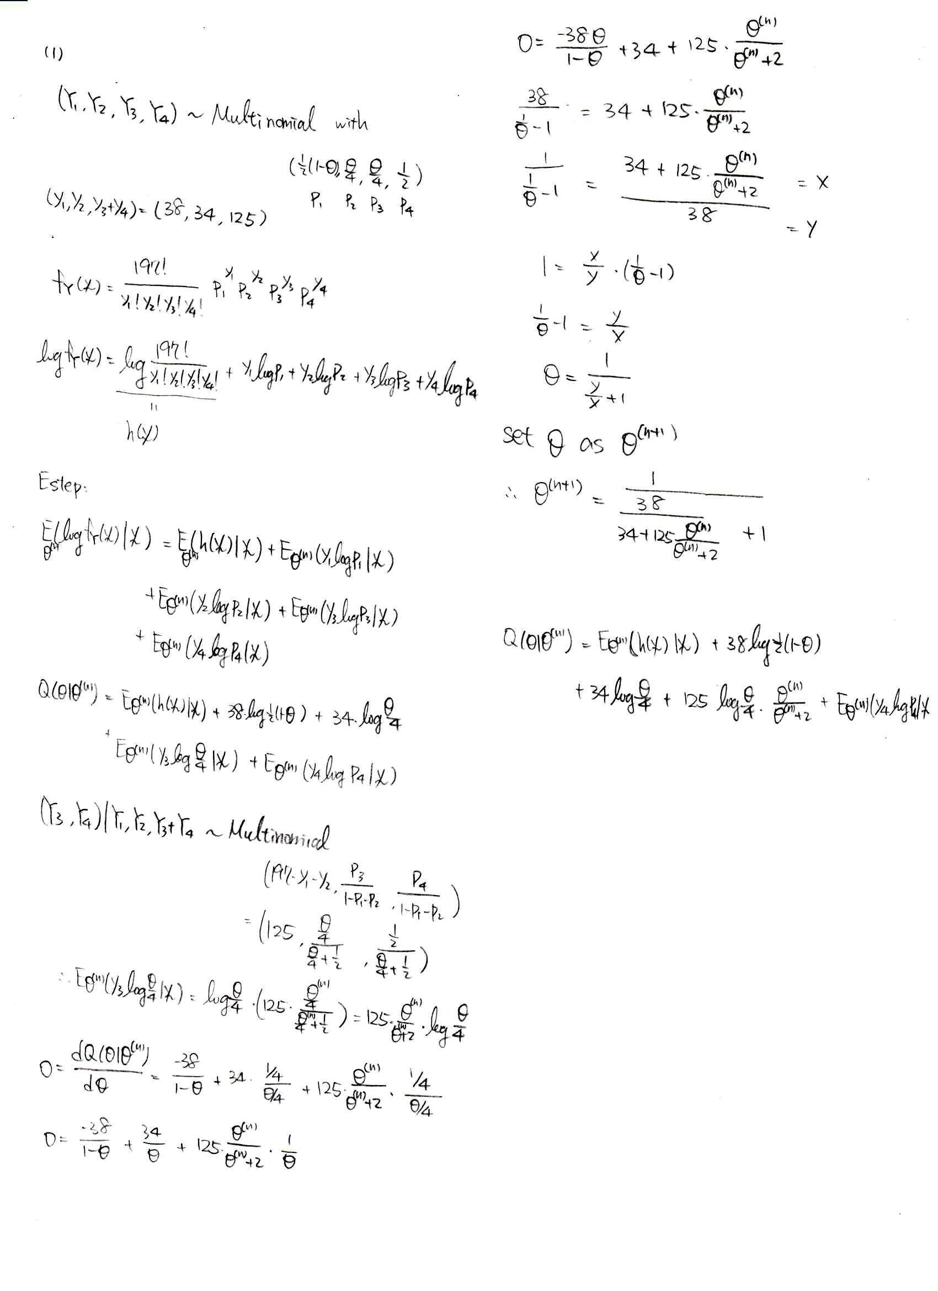

手寫推導(2):

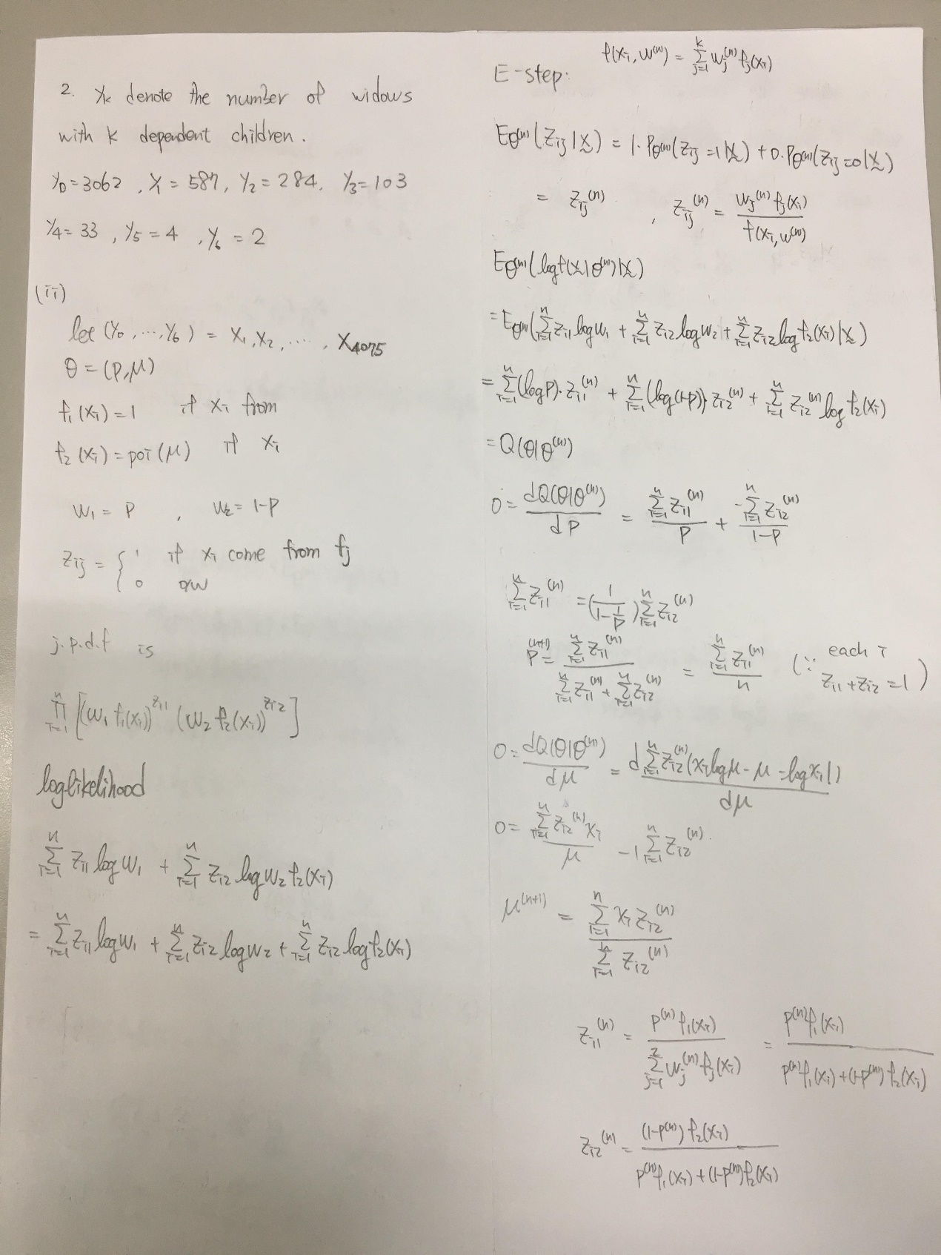

Coding-(1)

|  |
| --- |
| rm(list=ls())  graphics.off()  initialpar<-0.5  beforepar<-initialpar  conv<-FALSE  loop<-1  while(!conv){  newpar<-1/((38/(34+125*beforepar/(beforepar+2)))+1)  afterpar<-newpar  cat("now is:",loop,"th loop and (n+1)th theta is:",afterpar,"(n+1)th theta - nth theta is:",abs(afterpar-beforepar),"\n")  if(abs(afterpar-beforepar)<10^-7){conv<-TRUE ; break} else{loop<-loop+1}  beforepar<-afterpar  } |

Coding-(2)

|  |
| --- |
| #####  rm(list=ls())  graphics.off()  #####  #(i)  N<-c(3062,587,284,103,33,4,2)  N1<-3062*0+1*587+284*2+3*103+4*33+5*4+2*6  lamda_hat<-N1/4075  p<-c()  for(i in 1:7){  p<-c(p,dpois((i-1),lamda_hat))  }  a<-0  for(j in 1:7){  a<-a+(N[i]-N1*p[i])^2/(N1*p[i])  }  if(pchisq(a,6,lower.tail = FALSE)<0.05){  cat("the kolmogorov-Smirnov test p-value is:",pchisq(a,6,lower.tail = FALSE),"\n")  cat("we reject H0","\n")  } else{  cat("the kolmogorov-Smirnov test p-value is:",pchisq(a,6,lower.tail = FALSE),"\n")  cat("we didn't reject H0","\n")  }  #####  #(ii)  rm(list=ls())  graphics.off()  y0<-rep(0,3062)  y1<-rep(1,587)  y2<-rep(2,284)  y3<-rep(3,103)  y4<-rep(4,33)  y5<-rep(5,4)  y6<-rep(6,2)  initial.p<-0.75  initial.u<-0.4  x<-c(y0,y1,y2,y3,y4,y5,y6)  computez1<-function(i,p,u,x){  y<-(u^x*exp(-u))/factorial(x)  if(i <=3062){  return(p/(p+(1-p)*y))  } else{return(0)}  }  computez2<-function(i,p,u,x){  y<-(u^x*exp(-u))/factorial(x)  if(i <=3062){  return(((1-p)*y)/(p+(1-p)*y))  } else{return(1)}  }  before.p<-initial.p  before.u<-initial.u  collect.p<-c()  collect.u<-c()  loop<-1  conv<-FALSE  cat("the initail parameter (p,u) is:(",initial.p,initial.u,")","\n")  while(!conv){  sum.z1<-0  sum.z2<-0  sum.xz2<-0  for(i in 1:length(x)){  comp.z1<-computez1(i,before.p,before.u,x[i])  comp.z2<-computez2(i,before.p,before.u,x[i])  sum.z1<-sum.z1+comp.z1  sum.z2<-sum.z2+comp.z2  sum.xz2<-sum.xz2+x[i]*comp.z2  }  after.p<-sum.z1/length(x)  after.u<-sum.xz2/sum.z2  collect.p<-c(collect.p,after.p)  collect.u<-c(collect.u,after.u)  cat("now loop is:",loop,"(n+1)th p is:",after.p,"(n+1)th u is:",after.u,"\n")  if(abs(after.p-before.p)<10^-6 && abs(after.u-before.u)<10^-6){conv<-TRUE} else{  loop<-loop+1  before.p<-after.p  before.u<-after.u  }  } |